\*\*\*\*\*\*\*\*\*\*\*\*\*\*\*\*\*\*\*\*\*\*\*\*\*\*\*\*\*\*\*\*\*\*\*\*\*\***Knime Tutorial\*\*\*\*\*\*\*\*\*\*\*\*\*\*\*\*\*\*\*\*\*\*\*\*\*\*\*\*\*\*\*\*\*\*\*\*\*\*\*\*\*\*\*\*\*\***

**Introduction:-** Developing Machine Learning models is always considered very challenging due to its cryptic nature. Generally, to develop machine learning applications, we must be a good developer with an expertise in command-driven development. The introduction of KNIME has brought the development of Machine Learning models in the purview of a common man. KNIME Version Used >>>>4.0.0

KNIME provides a graphical interface (a user friendly GUI) for the entire development. In KNIME, we simply must define the workflow between the various predefined nodes provided in its repository. KNIME provides several predefined components called Nodes for various tasks such as reading data, applying various ML algorithms, and visualizing data in various formats. Thus, for working with KNIME, no programming knowledge is required.

So, [KNIME](https://www.geeksforgeeks.org/what-is-knime-analytics-platform/) is a one stop Data Analytics platform in which we can import, clean, manipulate data with single clicks. It is no code platform as it makes use of Nodes. Each node is a single entity that has some special functionality. The Nodes are connected to one another. In KNIME, we simply import our data, choose nodes, get the output and later on export the workflow. Workflow is the region where we drag and drop the nodes.

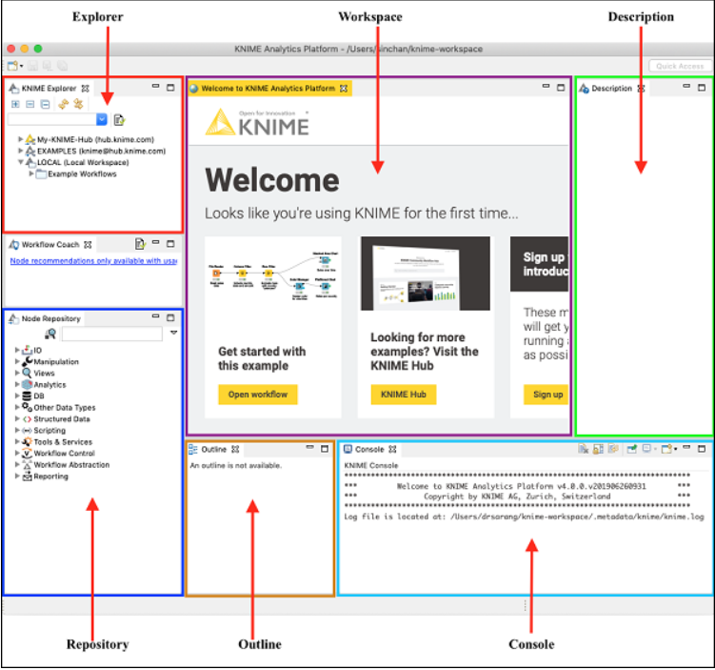**\*\*\*\*\*\*\*\*\*\*\*\*\*\*\*\*\*\*\*\*\*\*\*\*\*\*\*\*\*\*\*\*\*\*\*\*\*\*\*\*\*\*\*\*\*\*\*\*\*\*\*\*\*\*\*\*\*\*\*\*\*\*\*\*\*\*\*\*\*\*\*\*\*\*\*\*\*\*\*\*\*\*\*\*\*\*\*\*\*\*\*\*\*\*\*\*\*\***KNIME**- WorkBench:-** When KNIME starts, you will see the following screen –

As has been marked in the screenshot, the workbench consists of several views. The views which are of immediate use to us are marked in the screenshot and listed below −

* Workspace View
* Outline
* Nodes Repository
* KNIME Explorer
* Console
* Description
* 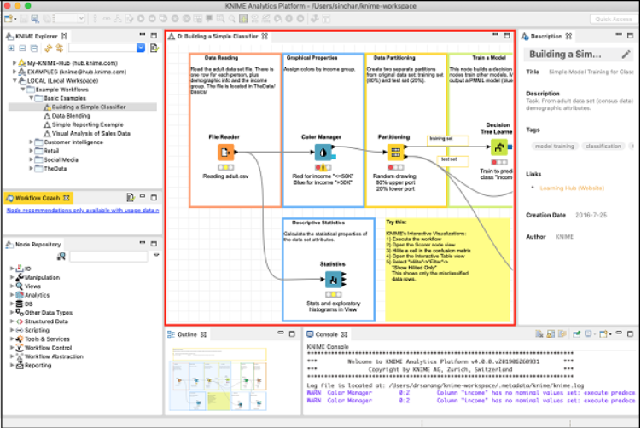**Workspace View:-** The most important view for us is the Workspace view. This is where we would create machine learning model. The workspace view is highlighted in the screenshot below –

Each workspace contains one or more nodes. The nodes are connected using arrows. Generally, the program flow is defined from left to right, though this is not required. We may freely move each node anywhere in the workspace. The connecting lines between the two would move appropriately to maintain the connection between the nodes. We may add/remove connections between nodes at any time. For each node a small description may be optionally added.

* **Outline View:-** The workspace view may not be able to show you the entire workflow at a time. That is the reason, the outline view is provided.

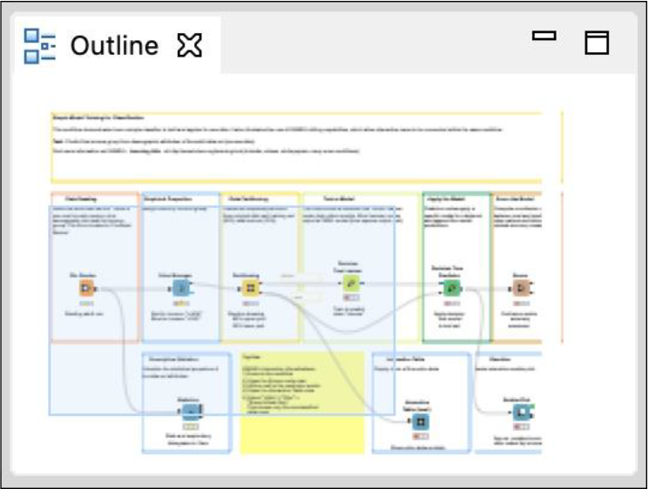The outline view shows a miniature view of the entire workspace. There is a zoom window inside this view that can slide to see the different portions of the workflow in the **Workspace** view.

* 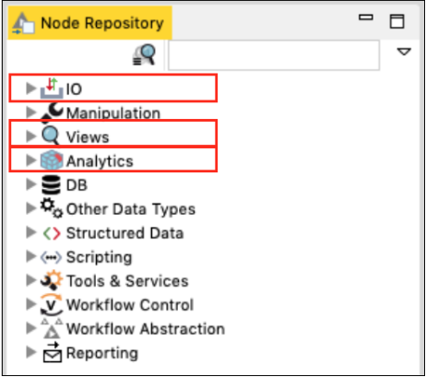**Node Repository: -**This is the next important view in the workbench. The Node repository lists the various nodes available for your analytics. The entire repository is nicely categorized based on the node functions. We will find categories such as − IO , Views , Analytics  
  Under each category we would find several options. Just expand each category view to see what we have there.

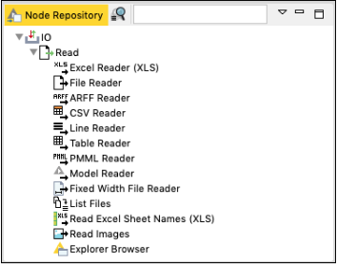Like, Under the IO category, we will find nodes to read data in various file formats, such as ARFF, CSV, PMML, XLS, etc.

Depending on input source data format, you will select the appropriate node for reading your dataset.

By this time, probably we understood the purpose of a node. A node defines a certain kind of functionality that we can visually include in our workflow.

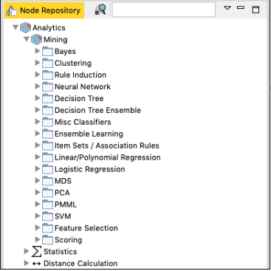The Analytics node defines the various machine learning algorithms, such as Bayes, Clustering, Decision Tree, Ensemble Learning, and so on.

The implementation of these various ML algorithms is provided in these nodes. To apply any algorithm in your analytics, simply pick up the desired node from the repository and add it to your workspace.

Connect the output of the Data reader node to the input of this ML node and your workflow is created.

* 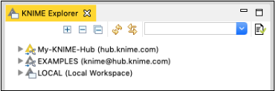**KNIME Explorer:-** The next important view in the workbench is the Explorer view as shown in the screenshot below −

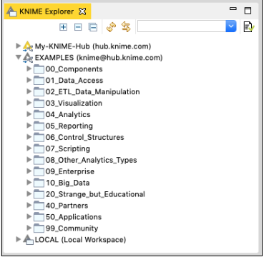The first two categories list the workspaces defined on the KNIME server. The third option LOCAL is used for storing all the workspaces that you create on your local machine. Try expanding these tabs to see the various predefined workspaces. Especially, expand EXAMPLES tab.

KNIME provides several examples to get you started with the platform.

* 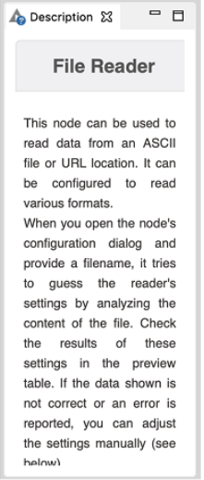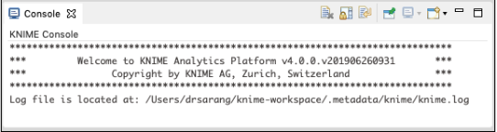**Console View:-** As the name indicates, the Console view provides a view of the various console messages while executing your workflow**.**

The Console view is useful in diagnosing the workflow and examining the analytics results.

* **Description  View:-** The last important view that is of immediate relevance to us is the Description view. This view provides a description of a selected item in the workspace. A typical view is shown in the screenshot below –

The above view shows the description of a **File Reader** node. When you select the **File Reader** node in your workspace, you will see its description in this view. Clicking on any other node shows the description of the selected node. Thus, this view becomes very useful in the initial stages of learning when you do not precisely know the purpose of the various nodes in the workspace and/or the nodes repository.

* **Toolbar:-** Besides the above described views, the workbench has other views such as toolbar. The toolbar contains various icons that facilitate a quick action. The icons are enabled/disabled depending on the context. You can see the action that each icon performs by hovering mouse on it. The following screen shows the action taken by Configure icon.
* 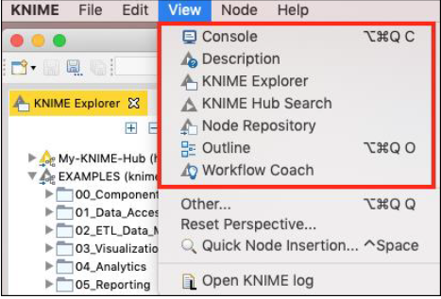**Enabling/Disabling Views:-** The various views that you have seen so far can be turned on/off easily. Clicking the Close icon in the view will close the view. To reinstate the view, go to the View menu option and select the desired view. The selected view will be added to the workbench.
* **Running First Workflow:-** KNIME has provided several good workflows for ease of learning. we shall pick up one of the workflows provided in the installation to explain the various features and the power of analytics platform. We will use a simple classifier based on a **Decision Tree** for our study.

**Loading Decision Tree Classifier**:- In the KNIME Explorer locate the following workflow −

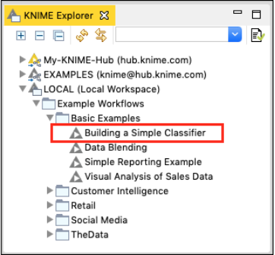**LOCAL / Example Workflows / Basic Examples / Building a Simple Classifier**

Double click on the selected item to open the workflow. Observe the Workspace view. You will see the workflow containing several nodes. The purpose of this workflow is to predict the income group from the democratic attributes of the adult data set taken from UCI Machine Learning Repository. The task of this ML model is to classify the people in a specific region as having income greater or lesser than 50K.

******************************************************************************  
**Project Intro:-** This statement describes the objective of a machine learning (ML) workflow that predicts income groups based on demographic attributes from the Adult dataset available in the UCI Machine Learning Repository.

1. Dataset: Adult Dataset (UCI Machine Learning Repository)

* This dataset is widely used for classification problems and contains demographic information about individuals, including:
  + Age, Education Level, Occupation, Marital Status, Race, Gender, Work Hours Per Week, Country of Residence, and more……

2. Objective: Income Group Prediction

* The workflow aims to **predict whether a person earns more or less than $50,000 per year**. This is a **binary classification problem**, meaning the model categorizes individuals into one of two income groups:
  + **Greater than $50K** (>50K) or **Less than or equal to $50K** (<=50K)

3. ML Model Task: Classification

* The **machine learning model** takes demographic features as input. It then **learns patterns** in the data and predicts income levels. This could be done using different classification algorithms like:
  + **Logistic Regression, Decision Trees**, **Random Forest**, **Support Vector Machines (SVM)**, **Neural Networks**

4. Application:-Such a model can be used for various real-world applications, including:

* + Targeted marketing
  + Socio-economic studies
  + Employment pattern analysis
  + Financial risk assessments

**Summary:-** This workflow is a **supervised machine learning model** that predicts whether an individual in a specific region earns **more or less than $50K per year**, based on their demographic attributes. The dataset used comes from the **UCI Machine Learning Repository**, and the task involves **binary classification** using various ML techniques.

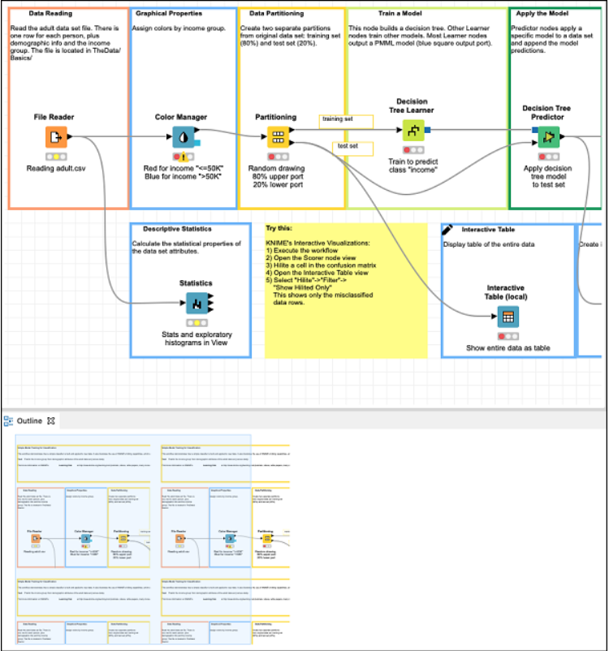**************************************************************************************************************************************The **Workspace** view along with its outline is shown in the screenshot below –

Notice the presence of several nodes picked up from the Nodes repository and connected in a workflow by arrows. The connection indicates that the output of one node is fed to the input of the next node.

**Executing Workflow:-** Before we investigate the execution of the workflow, it is important to understand the status report of each node. Examine any node in the workflow. At the bottom of each node, you would find a status indicator containing three circles. The Decision Tree Learner node is shown in the screenshot below –

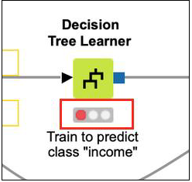The status indicator is red indicating that this node has not been executed so far. During the execution, the center circle which is yellow in color would light up. On successful execution, the last circle turns green. There are more indicators to give you the status information in case of errors. You will learn them when an error occurs in the processing.

Note that currently the indicators on all nodes are red indicating that no node is executed so far. To run all nodes, click on the following menu item –

After a while, you will find that each node status indicator has now turned green indicating that there are no errors.

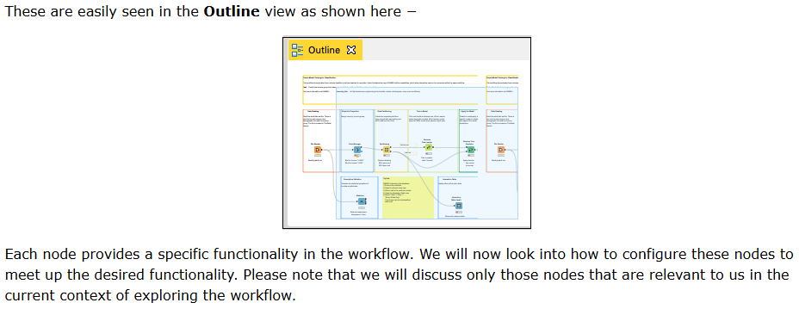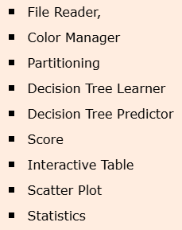If you check out the nodes in the workflow, you can see that it contains the following –

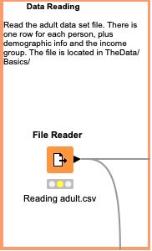**File Reader:-** The File Reader node is depicted in the screenshot below –

There is some description at the top of the window that is provided by the creator of the workflow. It tells that this node reads the adult data set. The name of the file is adult.csv as seen from the description underneath the node symbol. The File Reader has two outputs - one goes to **Color Manager** node and the other one goes to **Statistics node.**

**If you right click the File Manager, a popup menu would show up as below –**

The **Configure** menu option allows for the node configuration. The **Execute** menu runs the node. Note that if the node has already been run and if it is in a green state, this menu is disabled.

Also, note the presence of **Edit Note Description** menu option. This allows you to write the description for your node.

Now, select the **Configure** menu option, it shows the screen containing the data from the adult.csv file as seen in the screenshot here –

When you execute this node, the data will be loaded in the memory. The entire data loading program code is hidden from the user. You can now appreciate the usefulness of such nodes - **no coding required.**

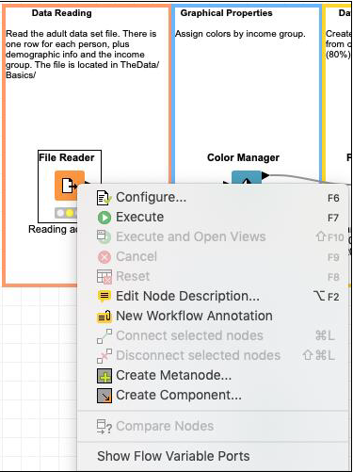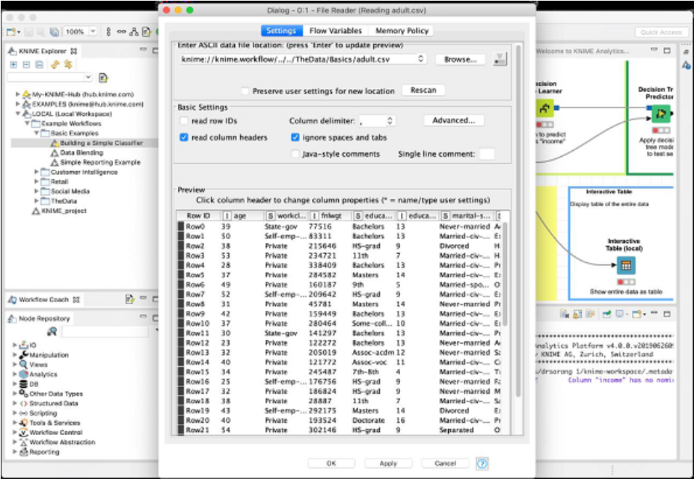Our next node is the Color Manager.

**Color Manager:-** Select the Color Manager node and go into its configuration by right clicking on it. A colors settings dialog would appear. Select the income column from the dropdown list. Your screen would look like the following –

Notice the presence of two constraints.  
 If the income is less than 50K, the datapoint will acquire green color and if it is more, it gets red color.   
You will see the data point mappings when we look at the scatter plot later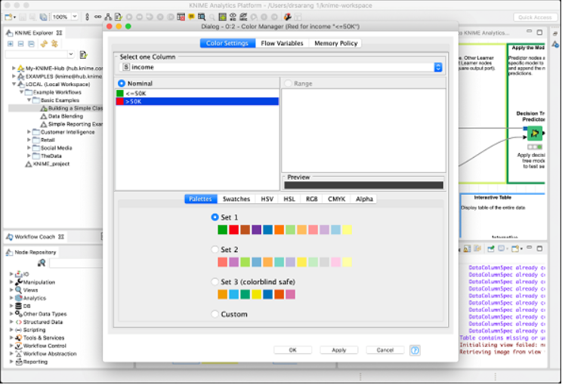.

**Partitioning** :- In machine learning, we usually split the entire available data in two parts. The larger part is used in training the model, while the smaller portion is used for testing. There are different strategies used for partitioning the data.

To define the desired partitioning, right click on the Partitioning node and select the Configure option. You would see the following screen −

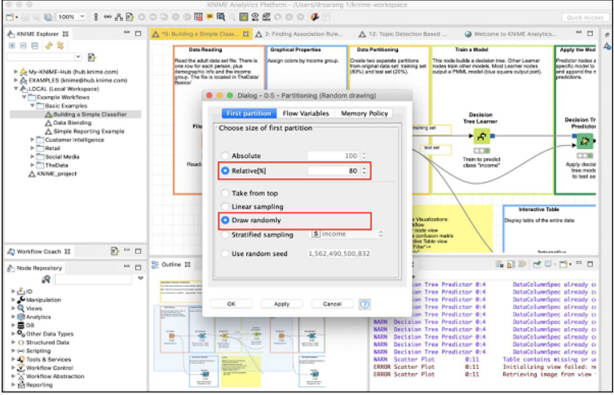

In the case, the system modeler has used the **Relative** (%) mode, and the data is split in 80:20 ratio. While doing the split, the data points are picked up randomly. This ensures that your test data may not be biased. In case of Linear sampling, the remaining 20% data used for testing may not correctly represent the training data as it may be totally biased during its collection.

If you are sure that during data collection, the randomness is guaranteed, then you may select the linear sampling. Once your data is ready for training the model, feed it to the next node, which is the **Decision Tree Learner**.

**Decision Tree Learner:-** The Decision Tree Learner node as the name suggests uses the training data and builds a model. Check out the configuration setting of this node, which is depicted in the screenshot below –

As you see the **Class** is **income**. Thus, the tree would be built based on the income column and that is what we are trying to achieve in this model. We want a separation of people having income greater or lesser than 50K.

After this node runs successfully, your model would be ready for testing.

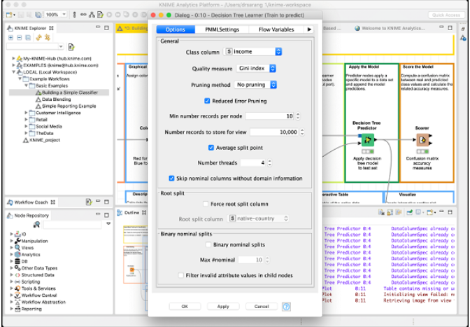

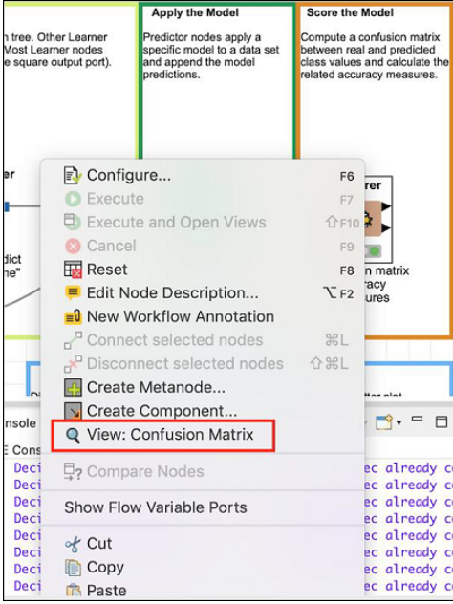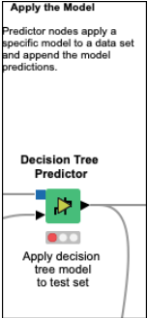**Decision Tree Predictor:-** The Decision Tree Predictor node applies the developed model to the test data set and appends the model predictions. The output of the predictor is fed to two different nodes - **Scorer** and **Scatter Plot**. Next, we will examine the output of prediction.

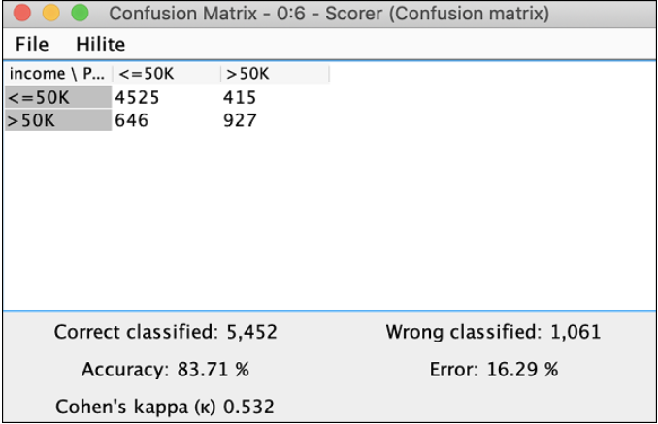**Scorer:-** This node generates the **confusion matrix**. To view it, right click on the node. You will see the following popup menu :-   
  
It indicates that the accuracy of our developed model is 83.71%. If you are not satisfied with this, you may play around with other parameters in model building, especially, you may like to revisit and cleanse your data.

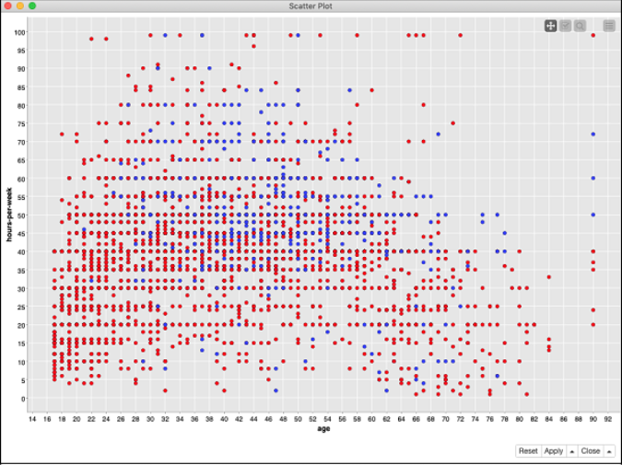**Scatter Plot:-** To see the scatter plot of the data distribution, right click on the **Scatter Plot** node and select the menu option **Interactive View: Scatter Plot**. You will see the following plot –

The plot gives the distribution of different income group people based on the threshold of 50K in two different colored dots - **red and blue.** These were the colors set in our Color Manager node. The distribution is relative to the age as plotted on the x-axis.

You may select a different feature for x-axis by changing the configuration of the node.

**\*\*\*\*\*Sample Project\*\*\*\*\*\*\*\***  
  
**Building Your Own Model**:- We will build your own machine learning model to categorize the plants based on a few observed features. We will use the well-known iris dataset from UCI Machine Learning Repository for this purpose.

**IRIS DATASET LINK:-** <https://archive.ics.uci.edu/dataset/53/iris>

The dataset contains three different classes of plants. We will train our model to classify an unknown plant into one of these three classes.

We will start with creating a new workflow in KNIME for creating our machine learning models.

**Creating Workflow:-** To create a new workflow, select the following menu option in the KNIME workbench.

**Preparing Dataset:-** Download the iris dataset from the UCI Machine Learning Repository site. Link attached above.

The downloaded iris.data file is in CSV format. We will make some changes in it to add the column names.

Open the downloaded file in your favorite text editor and add the following line at the beginning.



When our **File Reader** node reads this file, it will automatically take the above fields as column names. Now, we will start adding various nodes.

* **Adding File Reader:-** Go to the Node Repository view, type “file” in the search box to locate the File Reader node.

Select and double click the **File Reader** to add the node into the workspace. Alternatively, you may use drag-n-drop feature to add the node into the workspace. After the node is added, we will have to configure it. Right click on the node and select the **Configure** menu option.  
  
The settings screen looks like the following after the datafile is loaded.

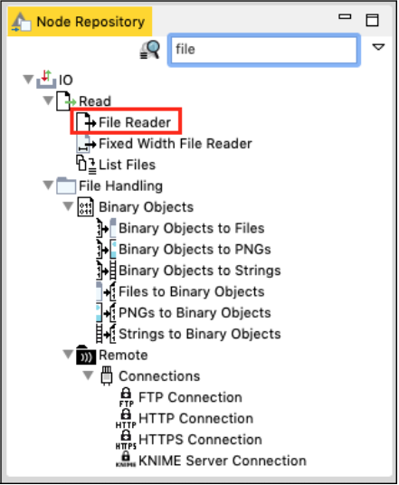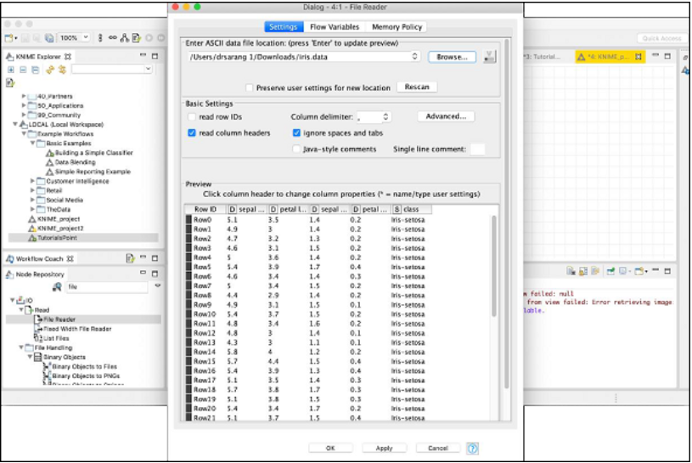To load your dataset, click on the **Browse** button and select the location of your iris.data file. The node will load the contents of the file which are displayed in the lower portion of the configuration box. Once you are satisfied that the datafile is located properly and loaded, click on the **OK** button to close the configuration dialog.

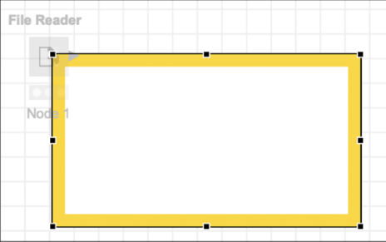You will now add some annotation to this node. Right click on the node and select **New Workflow Annotation** menu option. An annotation box would appear on the screen as shown in the screenshot here:

Click inside the box and add the following annotation –

Click anywhere outside the box to exit the edit mode. Resize and place the box around the node as desired. Finally, double click on the **Node 1** text underneath the node to change this string to the following −  
  
 At this point, your screen would look like the following –

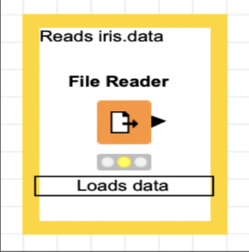  
  
We will now add a new node for partitioning our loaded dataset into training and testing.

* 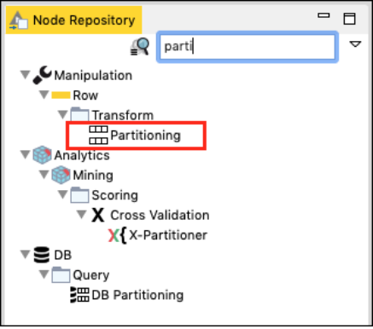**Adding Partitioning Node**:- In the Node Repository search window, type a few characters to locate the Partitioning node, as seen in the screenshot below −  
  Add the node to our workspace. Set its configuration as follows −

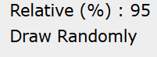

* 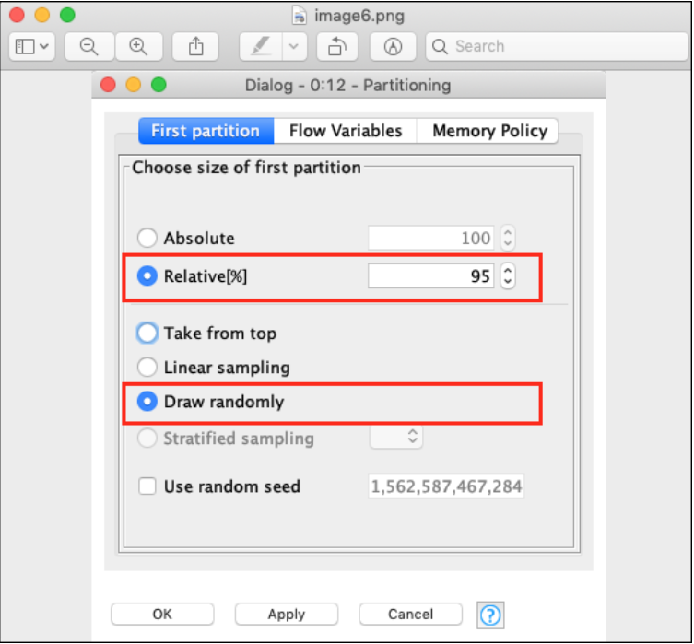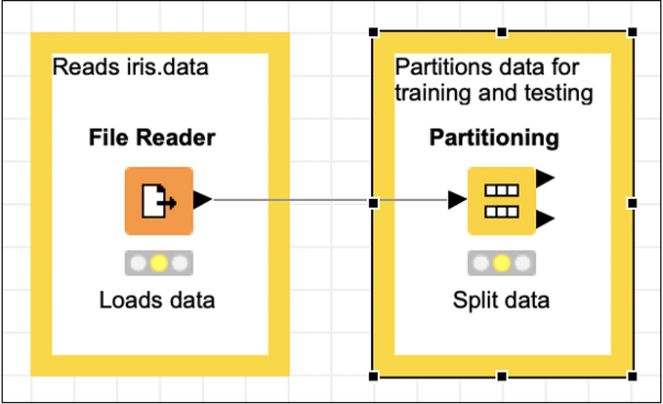The following screenshot shows the configuration parameters.  
  Next, make the connection between the two nodes. To do so, click on the output of the **File Reader** node, keep the mouse button clicked, a rubber band line would appear, drag it to the input of **Partitioning** node, release the mouse button. A connection is now established between the two nodes.  
  Add the annotation, change the description, position the node and annotation view as desired. Your screen should look like the following at this stage −  
  Next, we will add the **k-Means** node.
* **Adding k-Means Node:-** Select the k-Means node from the repository and add it to the workspace. If you want to refresh your knowledge on k-Means algorithm, just look up its description in the description view of the workbench. This is shown in the screenshot below −

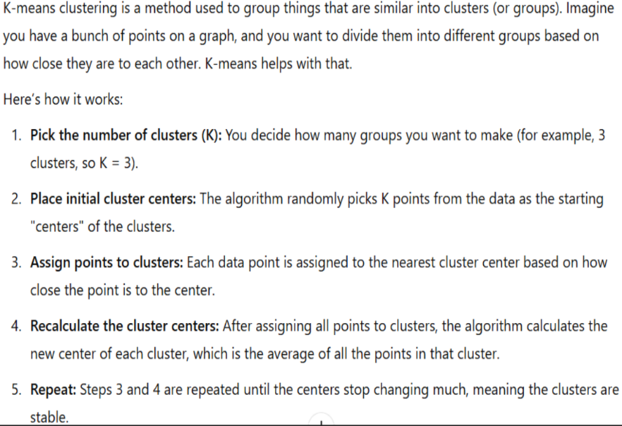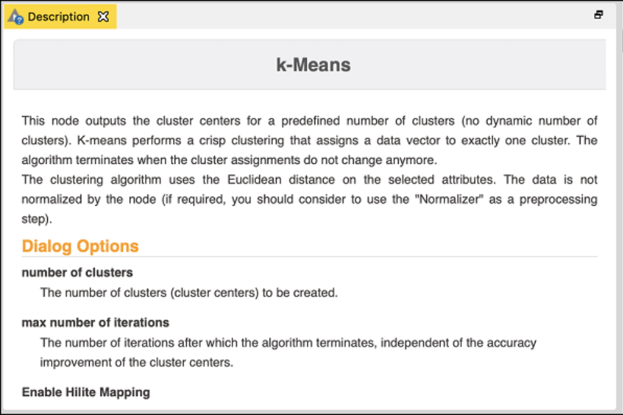Incidentally, you may look up the description of different algorithms in the description window before taking a final decision on which one to use.

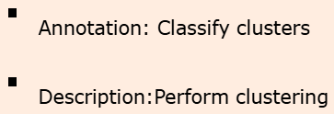Open the configuration dialog for the node. We will use the defaults for all fields as shown below:-   
Click **OK** to accept the defaults and to close the dialog.  
  
Set the annotation and description to the following −

Connect the top output of the **Partitioning** node to the input of **k-Means** node. Reposition your items and your screen should look like the following −

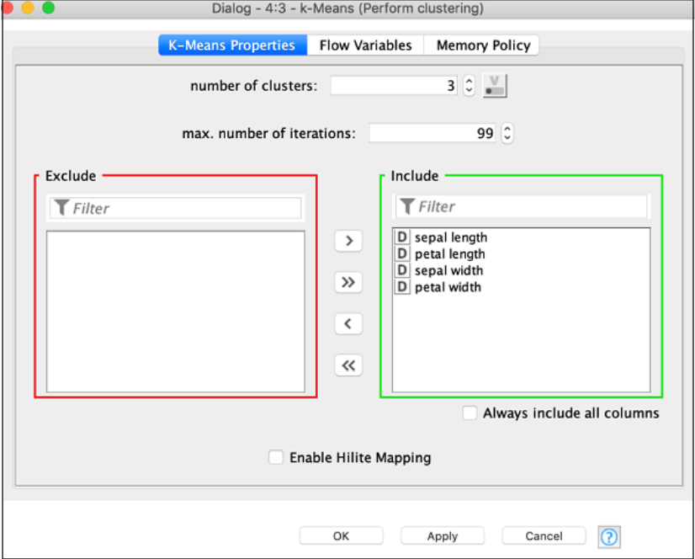

* 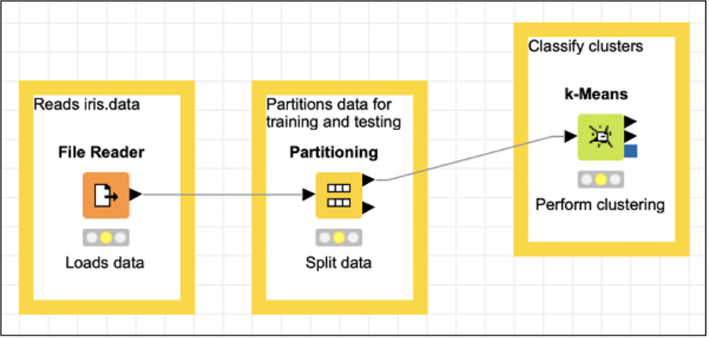  
    
    
    
    
    
    
    
    
    
    
    
    
    
  Next, we will add a **Cluster Assigner** node.
* **Adding Cluster Assigner:-** The Cluster Assigner assigns new data to an existing set of prototypes. It takes two inputs - the prototype model and the debatable containing the input data. Look up the node’s description in the description window which is depicted in the screenshot below –

Thus, for this node we have to make two connections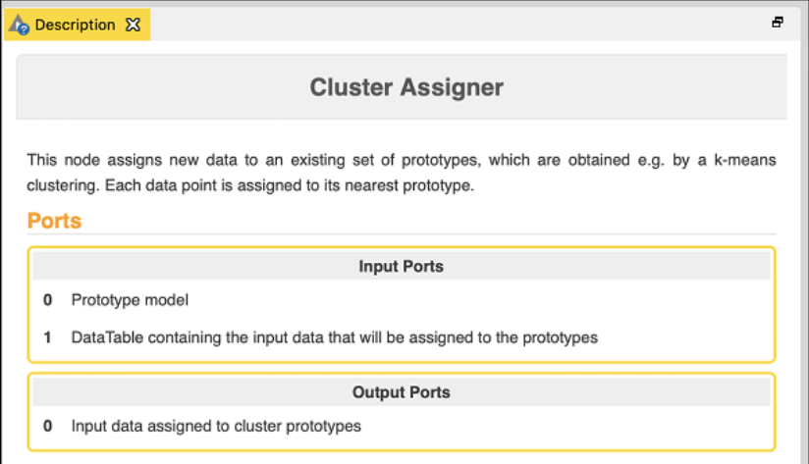:-

* The PMML Cluster Model output of **Partitioning** node → Prototypes Input of **Cluster Assigner**
* Second partition output of **Partitioning** node → Input data of **Cluster Assigner**

The **Cluster Assigner** does not need any special configuration. Just accept the defaults.

Now, add some annotation and description to this node. Rearrange your nodes. Your screen should look like the following –

At this point, our clustering is completed. We need to visualize the output graphically. For this, we will add a scatter plot. We will set the colors and shapes for three classes differently in the scatter plot. Thus, we will filter the output of the **k-Means** node first through the **Color Manager** node and then through **Shape Manager** node.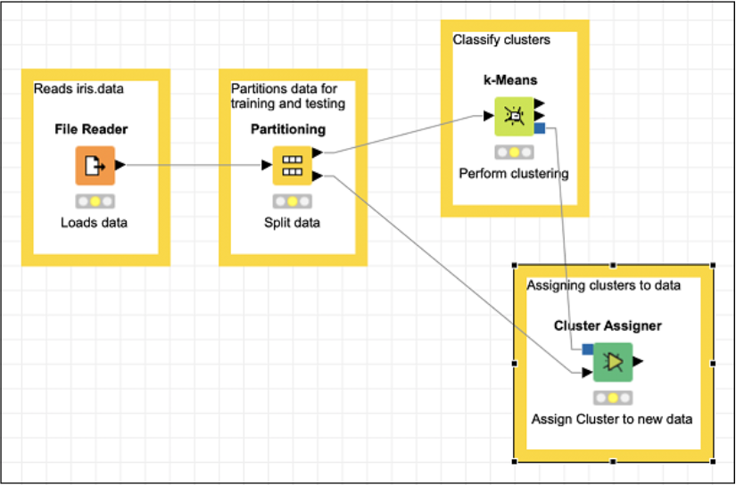

* **Adding Color Manager**:- Locate the Color Manager node in the repository. Add it to the workspace. Leave the configuration to its defaults. Note that you must open the configuration dialog and hit OK to accept the defaults. Set the description text for the node. Make a connection from the output of **k-Means** to the input of **Color Manager**.
* **Adding Shape Manager**:- Locate the Shape Manager in the repository and add it to the workspace. Leave its configuration to the defaults. Like the previous one, you must open the configuration dialog and hit OK to set defaults. Establish the connection from the output of Color Manager to the input of Shape Manager. Set the description for the node.

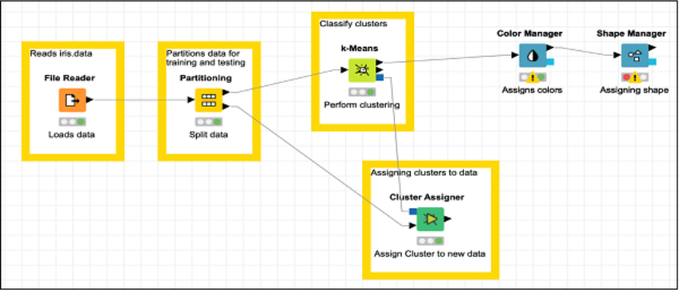Your screen should look like the following –

Now, we will be adding the last node in our model and that is the scatter plot.

* **Adding Scatter Plot**:- Locate Scatter Plot node in the repository and add it to the workspace. Connect the output of Shape Manager to the input of Scatter Plot. Leave the configuration to defaults. Set the description. Finally, add a group annotation to the recently added three nodes.



This completes the task of model building.

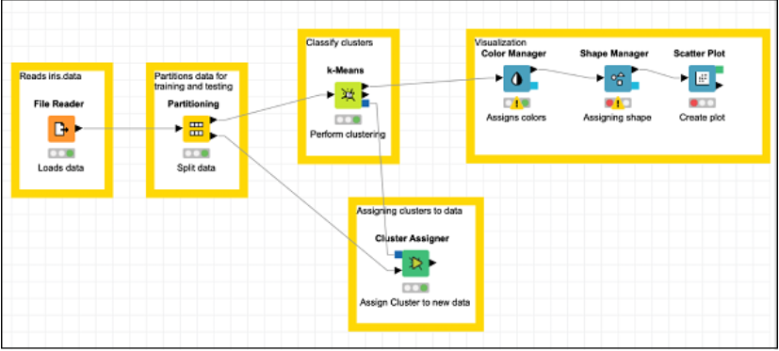

* **Testing the Model:-** To test the model, execute the following menu options: **Node → Execute All**

If everything goes correct, the status signal at the bottom of each node would turn green. If not, you will need to look up the Console view for the errors, fix them up and re-run the workflow.

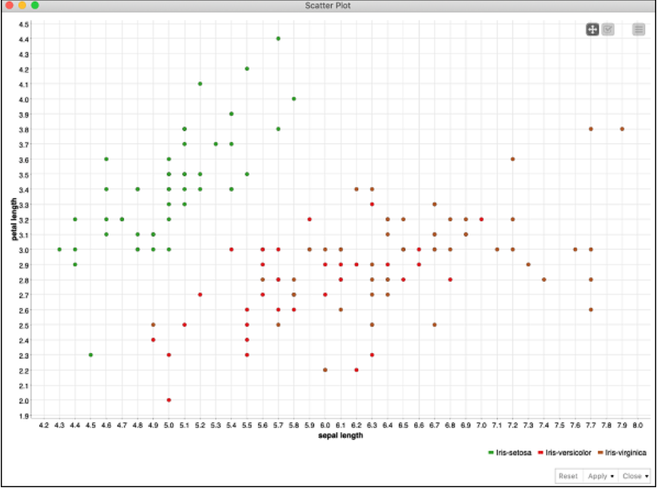Now, you are ready to visualize the predicted output of the model. For this, right click the **Scatter Plot** node and select the following menu options: **Interactive View: Scatter Plot**

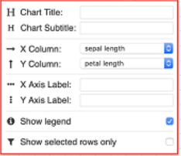You can run through different visualizations by changing x- and y- axis. To do so, click on the settings menu at the top right corner of the scatter plot. A popup menu would appear as shown in the screenshot below −